H2 Chemistry 9746 Preliminary Examinations 2009
Suggested Solutions
Paper 1: Multiple Choice Questions
Q1 | Q2 | Q3 | Q4 | Q5 | Q6 | Q7 | Q8 | Q9 | Q10
A | D | B | C | A | D | C | D | C | C
Q11 | Q12 | Q13 | Q14 | Q15 | Q16 | Q17 | Q18 | Q19 | Q20
D | D | C | D | B | C | A | D | B | D
Q21 | Q22 | Q23 | Q24 | Q25 | Q26 | Q27 | Q28 | Q29 | Q30
B | A | D | B | D | C | D | A | D | A
Q31 | Q32 | Q33 | Q34 | Q35 | Q36 | Q37 | Q38 | Q39 | Q40
B | A | B | D | A | B | C | C | B | D

Paper 2: Structured Questions
1 | (a) | (i) | 1s² 2s² 2p⁶ 3s² 3p⁶ 3d¹⁰ 4s¹
 |  | (ii) | Screening effect on the outermost electron of Cu is more or less the same as that in K, as the electrons in the d-subshell do not contribute significantly to screening effect
As nuclear charge of Cu > K, the attraction of the outermost electron by the nucleus of Cu is much stronger than in K
(⇒ atomic radius of Cu is smaller than K)
 |  | (iii) | As atomic radius of Cu < K, the copper atoms can pack close together / there will be more copper atoms per unit volume / copper would occupy a smaller volume for the same number of particles
As mass of one atom of Cu > mass of one atom of K,
hence density (mass / volume) of copper is higher than K.
 | (b) | (i) | (awarded as long as candidate mentions at least two of the bond energies in their answer)
   | HCl | HBr | HI
  Bond Energy (kJmol⁻¹) | 431 | 336 | 229
 |  |  | ease of breaking the H−X bond: HCl < HBr < HI
 |  |  | thermal stability: HCl > HBr > HI
 |  | (ii) | Hydrogen bonding exist between HF molecules
 | (c) | 1st I.E.: He = 2370 kJ mol⁻¹; Ne = 2080 kJ mol⁻¹
 |  | Potential difference required = 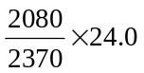= 21.1 V
 |  |  | [Total: 11]

2 | (a) | (i) | 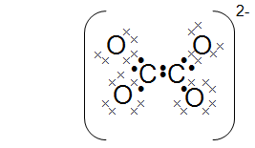
 |  | (ii) | 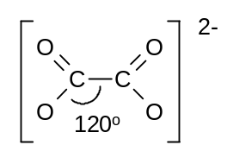
 |  |  | trigonal planar with respect to both carbon
 |  |  | bond angle = 120°
 | (b) | (i) | The experiment should be conducted in the fume cupboard to prevent inhalation of the toxic CO(g).  (Or any feasible precaution, but must mention the toxic nature of CO. Vague reasons, such as CO is a pollutant, are not accepted.)
 |  | (ii) | amount of CaC₂O₄ = 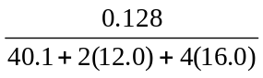= 1.0 × 10⁻³ mol
 |  |  | mass of B produced = 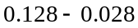 = 0.100 g
 |  |  | M_{r} of B = 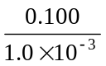 = 100
 |  | (iii) | CaCO₃
 |  | (iv) | CaC₂O₄ → CaCO₃ + CO
 |  | (v) | Any temperature well above 400 °C
ionic radius of Ba²⁺ > ionic radius of Ca²⁺
or
charge density of Ba²⁺ < charge density of Ca²⁺
 |  |  | Ba²⁺ ion is less able to polarise / distort electron cloud of the anion.
 |  |  | [Total: 12]

3 | (a) | (i) | A is: | 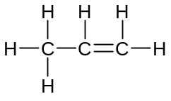
 |  |  | B is: | 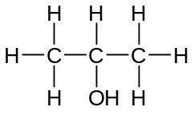
 |  | (ii) | Step II: H₃PO₄, steam, 300 °C, 70 atm  or cold conc H₂SO₄, reflux, followed by H₂O and heat
 |  |  | Step III: KMnO₄ / K₂Cr₂O₇, H₂SO₄(aq), heat / reflux
 | (b) | (i) | HCN + NaOH → Na⁺ + CN⁻ + H₂O
 |  | (ii) | 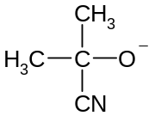  δ+  δ−  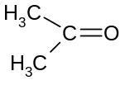  + ⁻:CN  slow  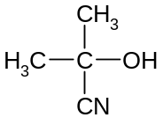  fast
+ H−CN
+ CN⁻

 |  | (iii) | H₂SO₄(aq) / HCl(aq), heat
 | (c) | (i)
 |  |  | 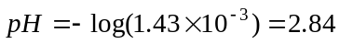
 |  | (ii) | 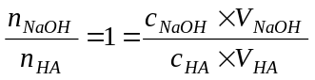  ⇒ 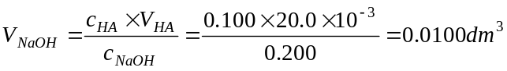 = 10.0 cm³
 |  | (iii) | A⁻ + H₂O → HA + OH⁻, pH = 8.5 (any value from 8 to 9)
 |  | (iv) | 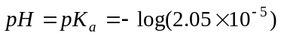 = 4.7
 |  | (v) | pH  7  4.7  0  10  5  volume of NaOH added/cm³
 |  | (vi) | Phenolphthalein. End point pH lies within the pH range of the indicator
 |  |  | [Total: 15]

4 | (a) | (i) | condensation reaction or electrophilic substitution
 |  | (ii) | ΔS will be negative.
 |  |  | Forward reaction is accompanied by a decrease in number of moles of particles.
 | (b) | (i) | 1 | For nucleophilic substitution of Cl by OH⁻ to take place.
 |  |  | 2 | To prevent the formation of Ag₂O (through the reaction of Ag⁺ and OH⁻)
 |  | (ii) | AgCl / silver chloride
 |  | (iii) | AgCl + 2NH₃ → [Ag(NH₃)₂]⁺Cl⁻  (must be balanced)
 |  | (iv) | D can be used to detect trichloroethanal.
 |  |  | Silver mirror / grey ppt (produced on warming)
 |  |  | [Total: 9]

5 | (a) | (i)
  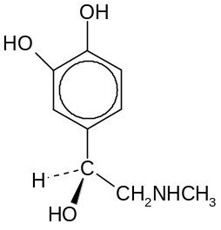 | 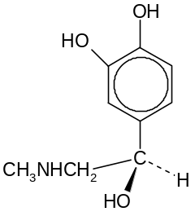
 |  | (ii)
  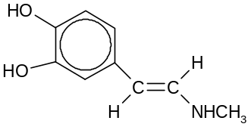 | 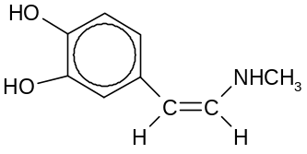
  trans−isomer | cis−isomer
 |  | (iii) | pK_{b} of benzedrin > pK_{b} of adrenaline
 |  |  | the lone pair of electrons on the N atom in adrenaline is more available for donation to H⁺ since it is attached to two electron donating alkyl groups.
 | (b) | (i) | Bronsted base or base or nucleophile
 |  | (ii) | Gas F: carbon dioxide or CO₂
 |  |  | Reagent: water or H₂O
 |  | (iii) | 1: | CH₃NH₂
 |  |  | 2: | C₆H₅NH₂
 |  | (iv) | Br₂(aq)
 |  |  | H decolourises Br₂(aq) and forms a white ppt and no decolourisation for G.
 |  |  | [Total: 13]

Paper 3: Free Response Questions
1 | (a)
  Element | 1st IE / kJ mol⁻¹ | 2nd IE / kJ mol⁻¹ | 3rd IE / kJ mol⁻¹ | 4th IE / kJ mol⁻¹
  Ca | 590 | 1150 | 4940 | 6480
  V | 648 | 1370 | 2870 | 4600
 |  | For element such as calcium, there is a significant difference between the 2nd and the 3rd IE (3790 kJmol⁻¹). Hence after losing 2 electrons, further ionisation requires a large energy input.
 |  | For transition metal such as vanadium, the 4s and 3d subshells have close proximity of the energy levels or the 3s or the 4s orbitals have almost the same energy. Hence vanadium can lose different number of 3d electrons in addition to the 4s electrons when forming stable compounds.
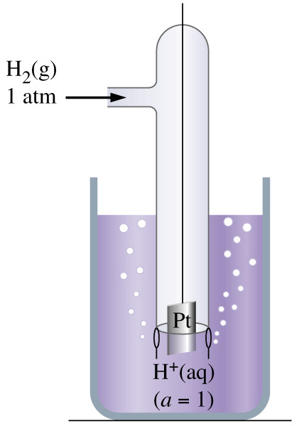

V
Salt Bridge
 | (b)  VO²⁺(aq), V³⁺(aq) and H⁺(aq) at  1 mol dm^{_3} | (i)  Pt | High resistance voltmeter  H₂ at 1atm, 25ºC  1.00  mol dm⁻³
 |  | (ii) | Stable oxidation state = +5  V³⁺ →VO²⁺ Eº_{cell} = (+0.98) − ( − 0.50) = +1.48 V, reaction is feasible  VO²⁺ → VO₂⁺ Eº_{cell} = (+0.98) − (+0.16) = +0.82 V, reaction is feasible
 |  | (iii) | Electrode potential values depend on the ligands present in the complex
 | (c) | V⁵⁺ has very high charge density and hence it will polarise the water molecules and weakens the O−H bonds in the water molecules  As a result, water molecules donates protons to form [VO₃(H₂O)₃]⁻ or simply VO₃⁻.
 | (d) | (i) | 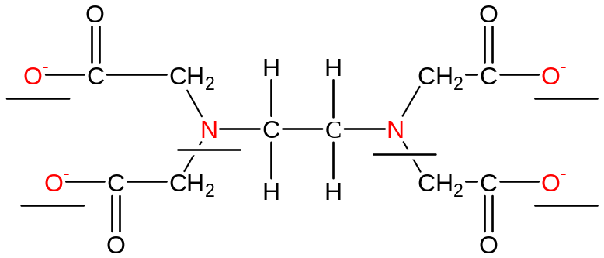
 |  | (ii) | Since K_{stab} [Cd(edta)]²⁻ >> K_{stab} [Ca(edta)]²⁻  Hence edta can remove the poisonous Cd²⁺ ions readily through the formation of the more stable [Cd(edta)]²⁻ complex.
 |  |  | Due to the close proximity (small difference in magnitude) in K_{stab} between [Cd(edta)]²⁻ and [Zn(edta)]²⁻, Zn²⁺ will also be removed in addition to Cd²⁺.
The unnecessary removal of metal ion, such as Zn²⁺, can be overcome by taking pills of Zn²⁺ supplement.
Or
Use another ligand that has a greater difference between the K_{stab} of Zn and Cd.
 | (e) | (i) | K_{sp} = [Mg²⁺(aq)] [OH⁻(aq)]² : units: mol³dm⁻⁹
 |  | (ii) | [Mg²⁺(aq)] in the saturated solution  = 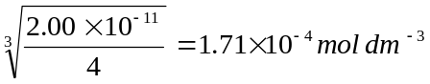
 |  | (iii) | [Mg²⁺(aq)] extracted = 0.0540 − 1.71 x 10⁻⁴ = 0.0538 moldm⁻³  Maximum % of Mg extracted = 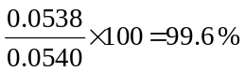
 |  | [Total: 20]

2 | (a) | (i) | M_{r} values are: C₃H₈O = 122.075, C₇H₆O₂ = 122.038, C₉H₁₄= 122.112  Y is C₈H₁₀O  (its relative molecular mass is closest to mass spectrum value)
 |  | (ii) | Reagent: C₂H₅OH or ethanol
 |  |  | Conditions: heat under reflux with concentrated sulfuric acid
 |  | (iii) | Any two of the following:
- a large hydrocarbon chain capable of adopting a ring like a hexagonal ring
- a short side-chain containing an electronegative atom such as oxygen
- a −CH₂O− side chain
 |  | (iv) | 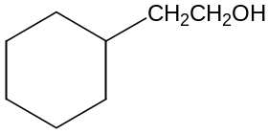
 | (b) | (i) | - Br₂, AlBr₃ / FeBr₃ / Fe fillings
 |  |  | - KMnO₄, H₂SO₄(aq), heat
 |  |  | - PCl₃ / PCl₅ / SOCl₂, (room temperature)
 |  | (ii) | - HCN, KCN / trace of NaOH, at 10 − 20°C
 |  |  | - H₂SO₄(aq) / HCl(aq), heat
 |  |  | - concentrated H₂SO₄, heat
 | (c) | Structures:
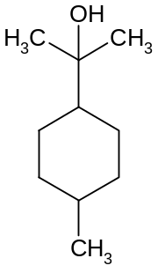 | 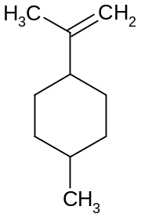 | 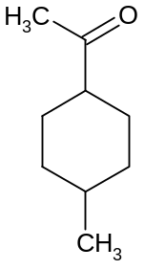
U | V | W
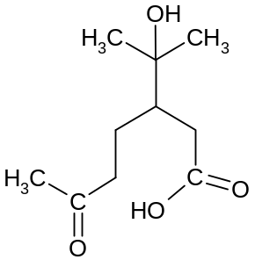 | 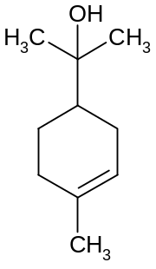
X | α−terpineol

 |  | Any 3 out of the following:
- α-Terpineol, C₁₀H₁₈O does not get oxidized readily. Hence α-terpineol is a tertiary alcohol.
- U, an alcohol, undergoes dehydration to form an alkene, V.
- Upon hydrogenation of α-terpineol, C₁₀H₁₈O, there is a increase in 2 H atoms. Hence, α-terpineol, C₁₀H₁₈O, has one double bond.
- Upon oxidative cleavage of α-terpineol, the product formed gives positive iodoform test: Y the oxidized product has methyl ketone gp / −COCH₃.
- V must have a terminal double bond which undergoes oxidative cleavage to form methyl ketone and CO₂.
 |  |  | [Total: 20]

3 | (a) | (i) | 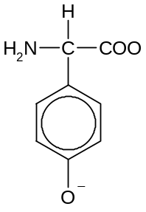  −
 |  | (ii) | 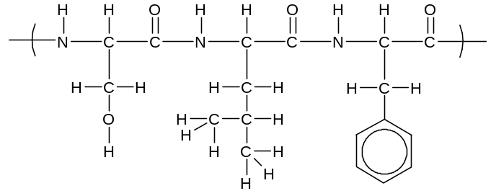  (all bonds must be shown)
 |  | (iii) | A diagram showing:
 |  |  | α-helix or β-pleated sheet showing the hydrogen bond between backbone amide and carboxyl groups
 |  |  | δ+ charge on the hydrogen atom, δ− charge on the nitrogen atom of the amide group, and the lone pair of electrons on the oxygen on the carboxyl group.
 |  | (iv) | B: | 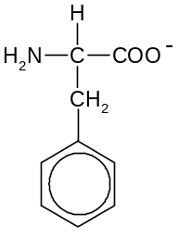
 |  |  | D: | 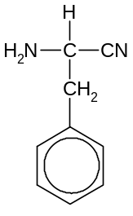
 |  |  | Step 1 : Ethanolic KCN, reflux
 | (b) | (i) | Let the rate equation be: rate = k [HCl]^{x}[sucrose]^{y}
Comparing experiment 1 and 2:
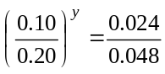 ⇒ y = 1
Comparing experiment 2 & 3:
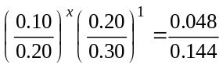 ⇒ x = 1
 |  |  | Hence rate = k [HCl][sucrose]
Using experiment 1:
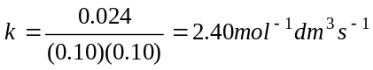 (including units)
 |  | (ii) | Half-life of sucrose in expt 3 = 1.5 s
In expt 3 (compared to expt 1), since [HCl] is doubled, rate is doubled.
Hence, rate at which [sucrose] is used up is 2 times faster.
⇒ Half life of sucrose is halved.
 | (c) | (i) | Let the percentage of the α-form in the equilibrium mixture be x.  (x/100)(+112) + [(100−x)/100] (+19) = +52  correct formula or attempt to relate % to optical rotation
 |  |  | ⇒ x = 35.5%
 |  | (ii) | 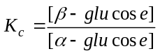
 |  |  | 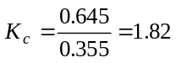
 |  | (iii) | At higher temperature,  equilibrium shift to the left to remove heat  Or  the backward reaction occurs to a greater extent as it is endothermic.
Therefore, [∝-glucose] increase.
⇒ Optical rotation will be greater than +52º.
 |  | [Total: 20]

4 | (a) | (i) | Cl₂ + 2OH⁻ → Cl ⁻ + ClO⁻ + H₂O
 |  | (ii) | Disproportionation is a process whereby a single species Cl₂ increases its oxidation state from 0 to +1 (ClO⁻) and decrease its oxidation state from 0 to -1 (Cl⁻) at the same time.
 | (b) | 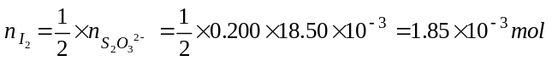
 |  | 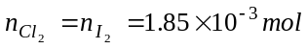
 |  | 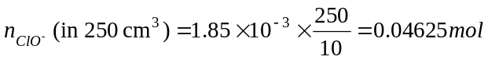
 |  | 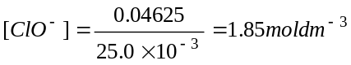
 | (c) | (i) | Lattice energy is defined as heat energy released when 1 mole of ionic solid is formed from its constituent gaseous ions under standard conditions.
 |  | (ii)  Na (s) + ½ Cl₂ (g) + ½ O₂ (g)  Na (g) + ½ Cl₂ (g) + ½ O₂ (g)  Na (g) + Cl (g) + ½ O₂ (g)  Na (g) + Cl (g) + O (g)  Na (g) + Cl-O (g)  Na⁺ (g) + Cl-O (g)  NaClO(s)  Energy  +107  ½ (+244)  ½ (+496)  −269  +494  −506  ΔH _{latt}  −564 | (energy level diagram not required)
 |  |  | By Hess’ law, ΔH _{latt} = −760 kJmol⁻¹
 |  | (iii) | ClO⁻ has a larger ionic radius than Cl⁻.
ClO⁻ has a lower charge density than Cl⁻, hence the electrostatic forces of attraction between Na⁺ and ClO⁻ is weaker.
Or
Since 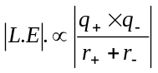
Therefore, the magnitude of lattice energy for NaClO will be less exothermic than NaCl.
 | (d) | (i) | 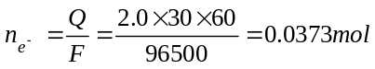
Since Cl₂ + 2e 2Cl⁻
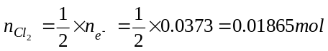
Using pV = nRT,
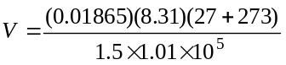
correct substitution of quantities into equation, and correct conversion of either temperature or pressure.
 |  |  | 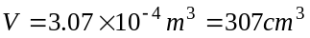
 |  | (ii) | High temperature and low pressure
 |  | (iii) | F₂ + 2e 2F– +2.87 V  O₂ + 4H⁺ + 4e 2 H₂O +0.40 V  E^{θ}_{red} (F₂ / F⁻) is much more positive than E^{θ}_{red} (O₂ / H₂O )
 |  |  | O₂ will always be preferentially discharged (rather than F₂ gas).
 |  | [Total: 20]

5 | (a) | (i) | NaCl – electrostatic attraction exist between oppositely charged ions in an ionic lattice
 |  |  | PCl₃ – covalent bonds exist between the P and Cl atoms to form discrete molecules.
 |  |  | Large difference in electronegativity between Na and Cl, hence, complete transfer of electrons – ionic compound; small difference in electronegativity between P and Cl, hence, atoms share electrons – covalent compound.
 |  |  | Large amount of energy required to overcome the strong ionic bonds between oppositely charged ions in NaCl, while much lesser energy is required to overcome weak intermolecular forces of attraction / vdw forces between PCl₃ molecules.
 |  | (ii) | Electrical conductivity
 |  |  | NaCl – able to conduct electricity in molten state as the ions are free to carry the charge, while PCl₃ does not contain mobile charge carriers in molten state.
 |  | (iii) | [Mg(H₂O)₆]²⁺ → [Mg(H₂O)₅(OH)]⁺ + H⁺
 |  | (iv) | Observations: white fumes of HCl is produced  (at the beginning when water was first added)
Reaction equation: PCl₃ + 3H₂O → H₃PO₃ + 3HCl
Or
PCl₃ hydrolyses completely in water to form HCl and H₃PO₃.
 |  |  | pH between 0 to 2
 | (b) | (i) | to supply the energy to break the Cl−Cl bond  (or to bring about homolytic cleavage)
 |  | (ii) | CH₃CH₂CH₂⋅ or any other radicals  (including the various chloro-substituted radicals)
 |  | (iii) | mole ratio of CH₃CH₂CH₂Cl : CH₃CHClCH₃ = 3:1
To produce CH₃CH₂CH₂Cl: the substitution can occur at any of the
6 H-atoms on the methyl carbon, while to produce CH₃CHClCH₃: substitution can only occur at 2 H-atoms on the −CH₂− carbon.
(therefore 3 times more CH₃CH₂CH₂Cl will be formed)
 | (c) | Structures: (relative positions of the 2 functional groups on the benzene ring is not important)
 |  | D: | 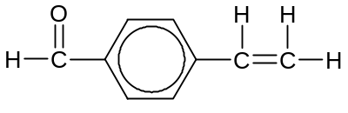
 |  | E: | 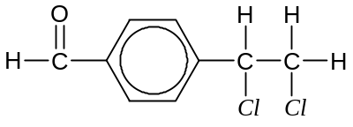
 |  | F: | 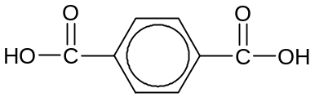
 |  | Any 3 out of the following explanations:
- D has a large hydrophobic group (the benzene ring), ∴does not dissolve in water

- D does not contain phenol and COOH group, ∴does not dissolve in NaOH
or
F contains COOH group, ∴can dissolve in NaOH

- D contains a C=C double bond, as it undergoes electrophilic addition with chlorine gas to form E.
or equation:

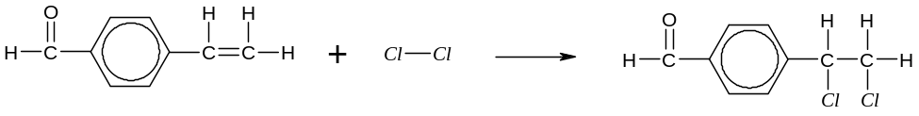

- D contains a benzaldehyde group, ∴does not react with Fehling’s solution but reacts with Tollen’s reagent

- The benzaldehyde group on D is oxidised to COOH group; and the alkene group undergoes oxidative cleavage to form a COOH group with hot acidified KMnO₄ to give F.
or equation:
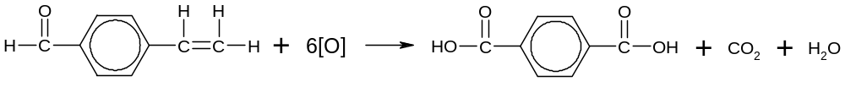
 |  | [Total: 20]

~ END OF PAPER ~

